GLASGOW MUSIC FESTIVAL
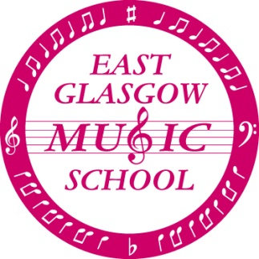

The orchestra and choirs will be performing at the Glasgow Music Festival on

Sunday 15th March 2020

The performances will take place in the Main Auditorium at The Glasgow Royal Concert Hall, Sauchiehall Street, Glasgow,G2 3NY
Orchestra: 14:00
Choirs: 15:20

TRANSPORT:
We will be providing buses to transport all the children from Eastbank. The first bus for the Orchestra will leave the school at 12:45. A second bus for the choirs will leave at 13:15. Please note that we will be meeting in the playground, there will be no access to the school.
I would like to encourage as many children as possible to travel to the Concert Hall on the bus as this makes it easier to keep children together when we arrive. However, parents wishing to take their children directly to the Concert Hall should ensure that they arrive no later than 13:15 (orchestra) or 13:45 (choirs). We must know in advance of your intention so that the buses don’t wait for you. Please let your child know how they will be travelling as this information will be gathered during choir/orchestra rehearsals.
Our waiting area at the Concert Hall is in the Clyde bar. Following our performances staff will escort all the children back to the Clyde bar where they may be collected if not returning on the bus.
Please ensure that you inform your child's group leader before leaving so that we know they are safe.
The performances should be finished at approximately 16:45 and a bus will return to Eastbank at approximately 17:15.

DRESS:
All children must be smartly dressed in school uniform consisting of SHIRT, TIE, TROUSERS/SKIRT, SCHOOL SHOES. Jumpers /Sweatshirts must be removed while performing.
Please AVOID the following: (this list is not exhaustive!!!) trainers, brightly coloured socks/tights, elaborate hair ornaments/jewellery, etc.

WHAT TO BRING:
Orchestra: ensure you have your instrument and spare strings/reeds
Children may bring a small drink/snack and a book or QUIET toy for any waiting times. Any expensive items are brought at your own risk.

AUDIENCE
Parents and friends are very welcome to come along and watch the performances. The Music Festival will charge for entry tickets to the hall.

We look forward to an enjoyable and successful afternoon.

